**CRRST TOOL**

Cloud Readiness Ruleset scanning tool

Contents

Objective: 3

Prerequisites: 3

Steps to Setup for CRRST tool. 4

Steps to create profile & apply rules 7

Stpes to scan java project in CRRST TOOL 14

Objective:

Steps required for installation of sonarqube with addition of mandatory dependencies to analysis the project. Configuration of profile which hold all the ruleset for PaaS candidate. This will also check the code quality of the other application. This tool scans only java projects with the help of maven.

Prerequisites:

* CRRST Ruleset jar file (1.0)
* Maven (3.0 onwards)
* JDK 8.0
* Sonarqube (Min 6.5 LTS)

# Steps to Setup for CRRST tool.

1. Go to following link to download sonarqube and click on download. (https://www.sonarqube.org/)

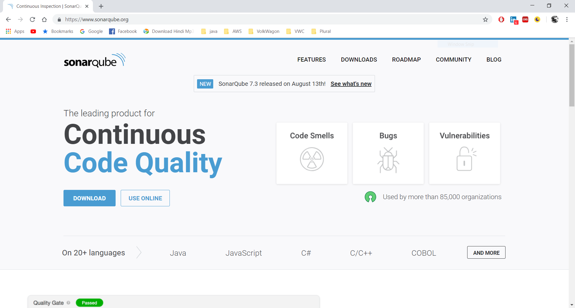

1. Click on community edition 7.3 or click on (<https://www.sonarqube.org/downloads/>)

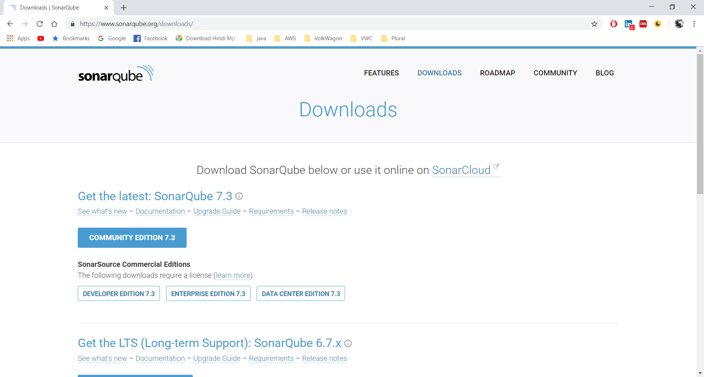

1. Extract sonarqube zip.
2. Go to **\sonarqube-7.3\sonarqube-7.3\extensions\plugins** and paste jar of CRRST rule.

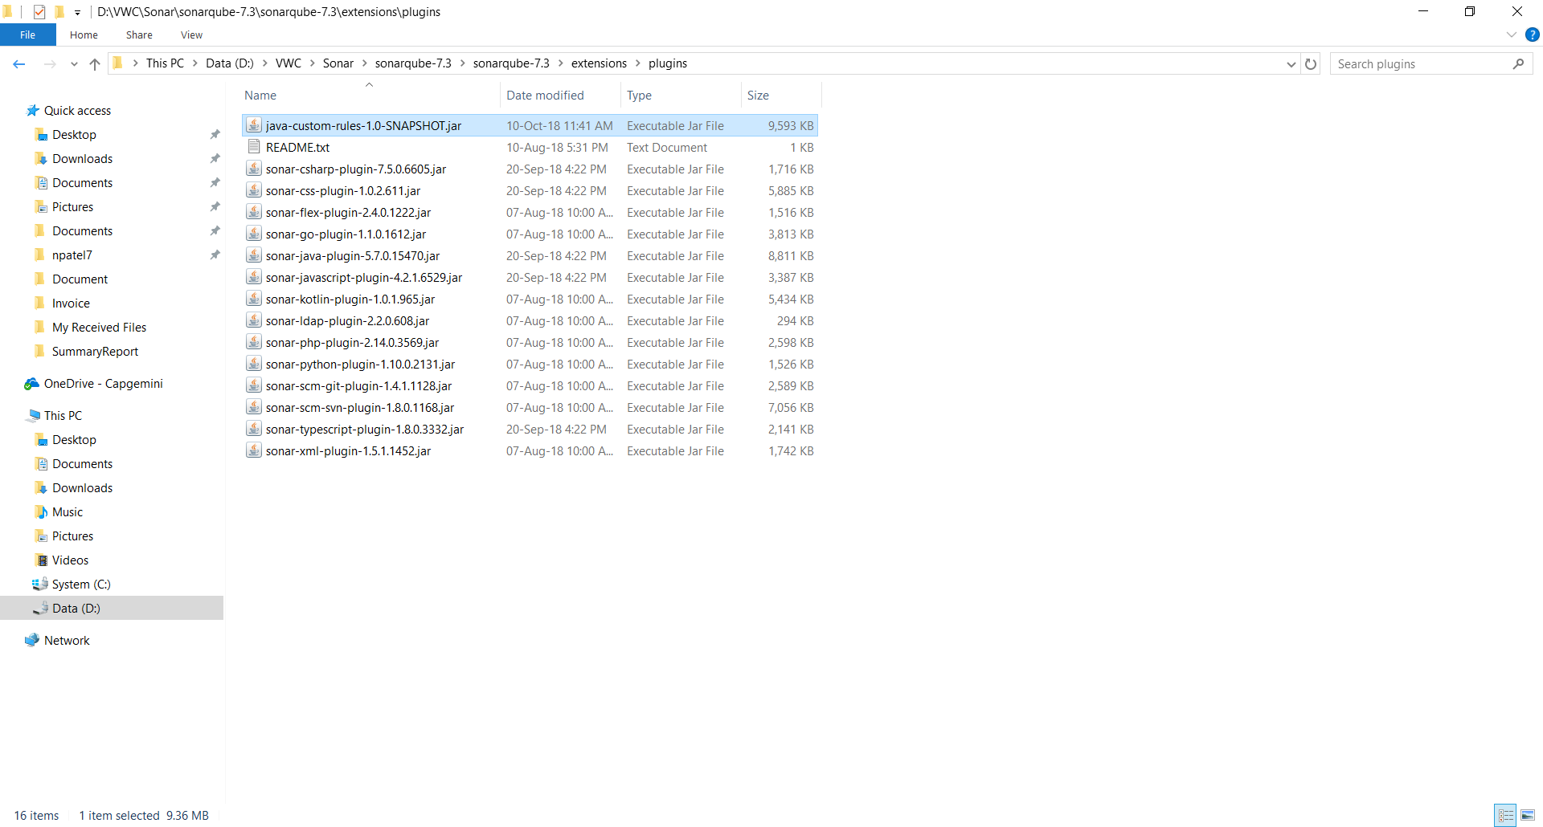

1. **Go to \sonarqube-7.3\sonarqube-7.3\bin\windows-x86-64** and double click on StartSonar.bat to run sonarqube.

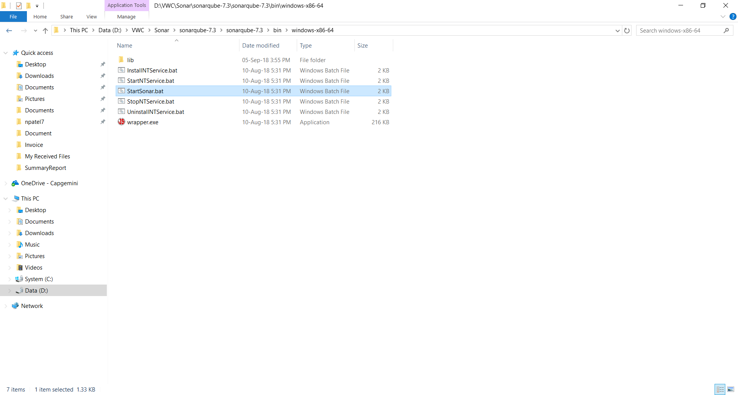

Note: There is also 32 bit version of sonarqube available for that go to \sonarqube-7.3\sonarqube-7.3\bin\windows-x86-32

1. It will open command prompt runs the necessary decencies & finally starts the sonarqube application.

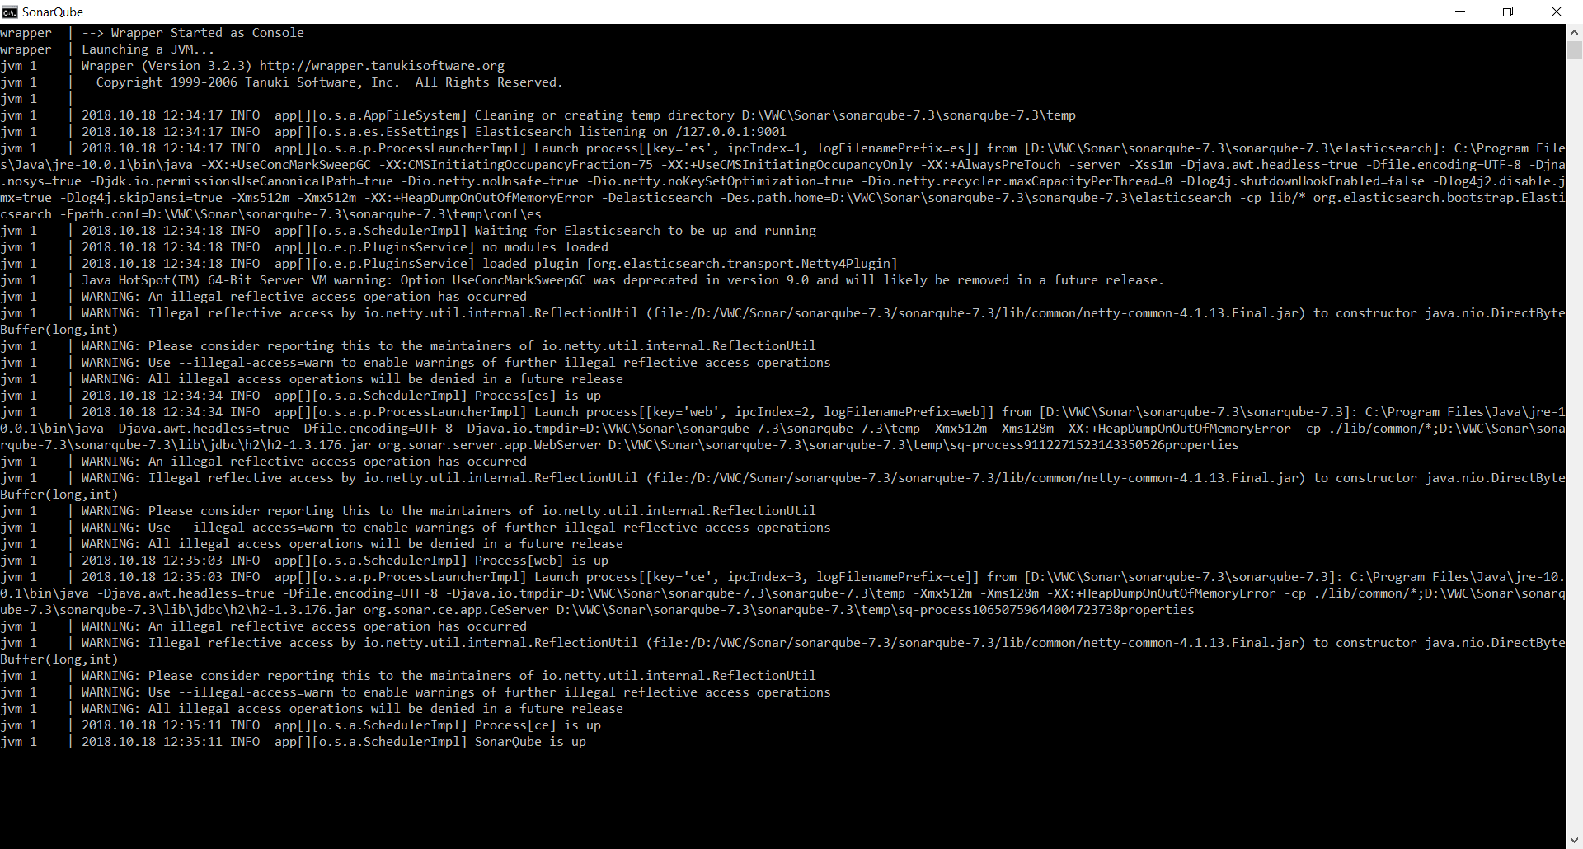

**Step 6:** Go to browser and enter localhost:9000 (by default sonarqube run on 9000 port)

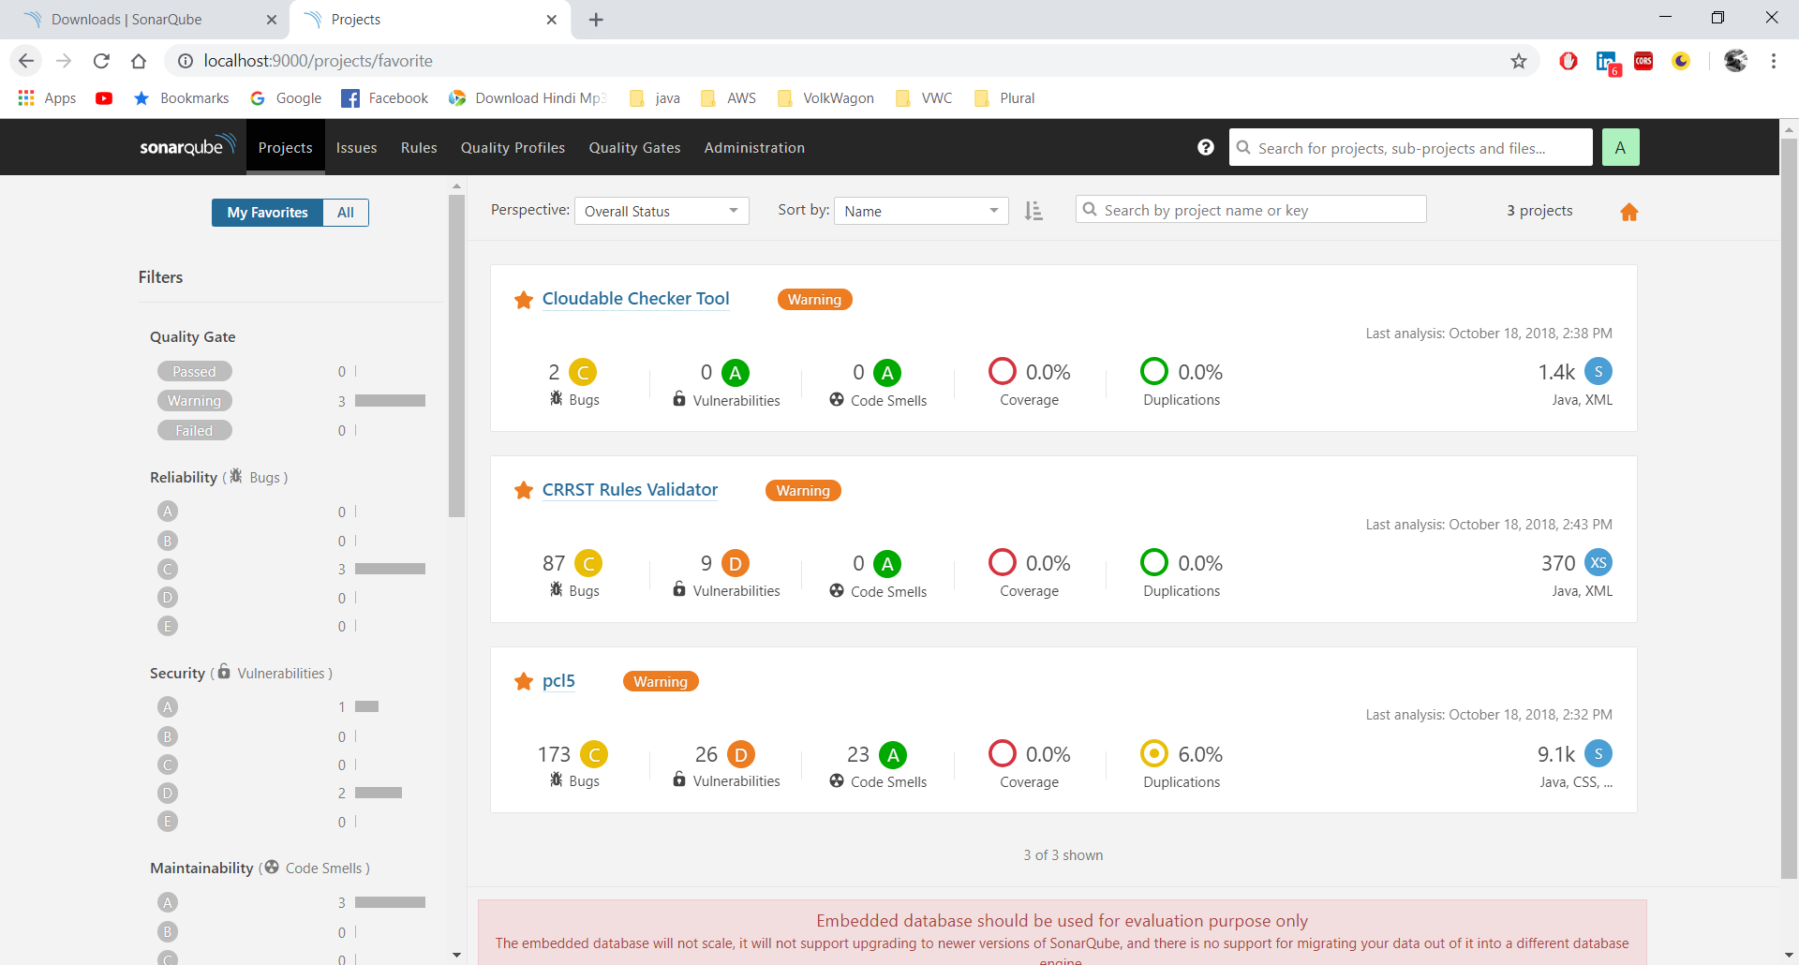

# Steps to create profile & apply rules

1. Click on Quality profile

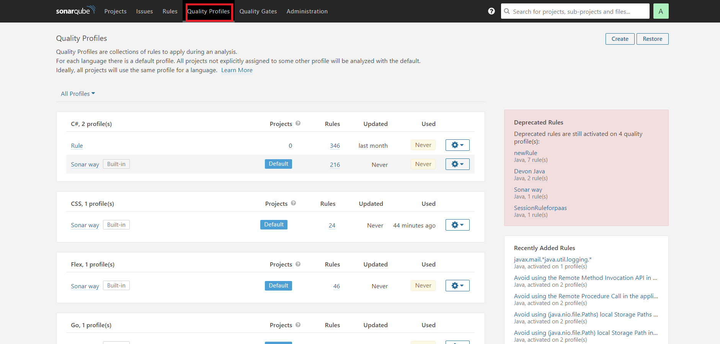

1. Click on create button.

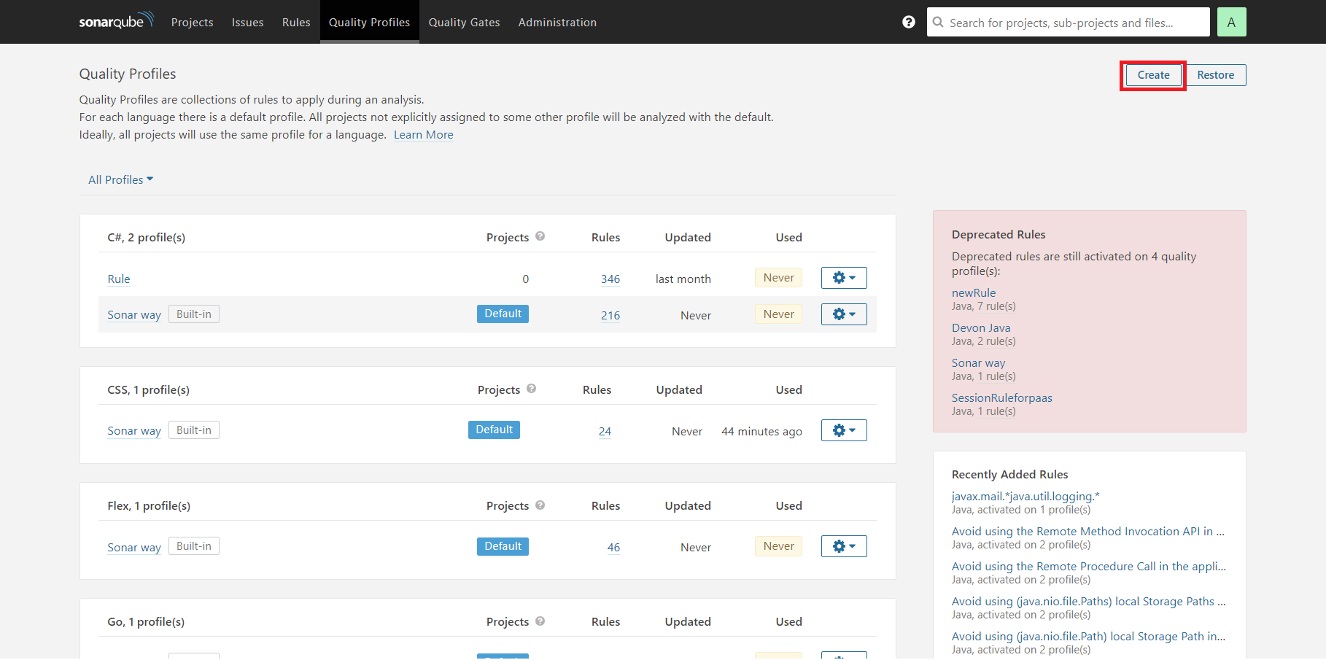

1. Enter any profile name in name and select language. (Name- CRRST Rules, Language- Java) and click on create.

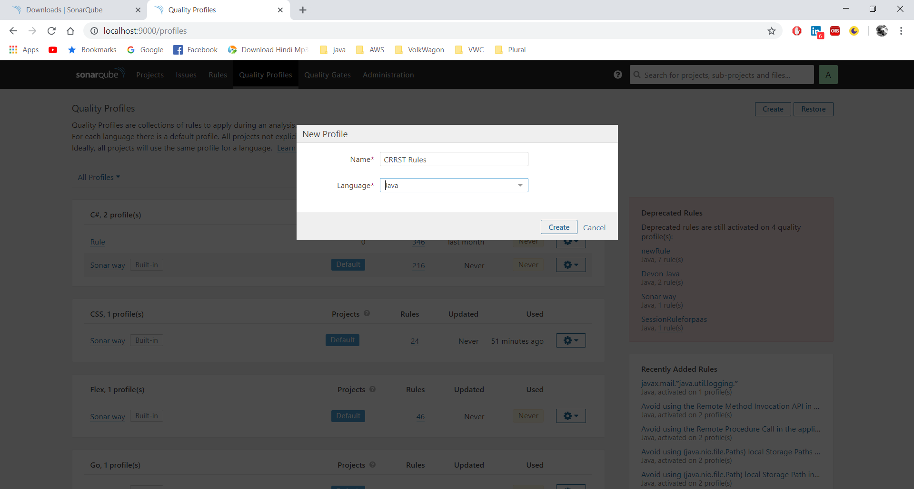

1. It will show profile’s rules dashboard.

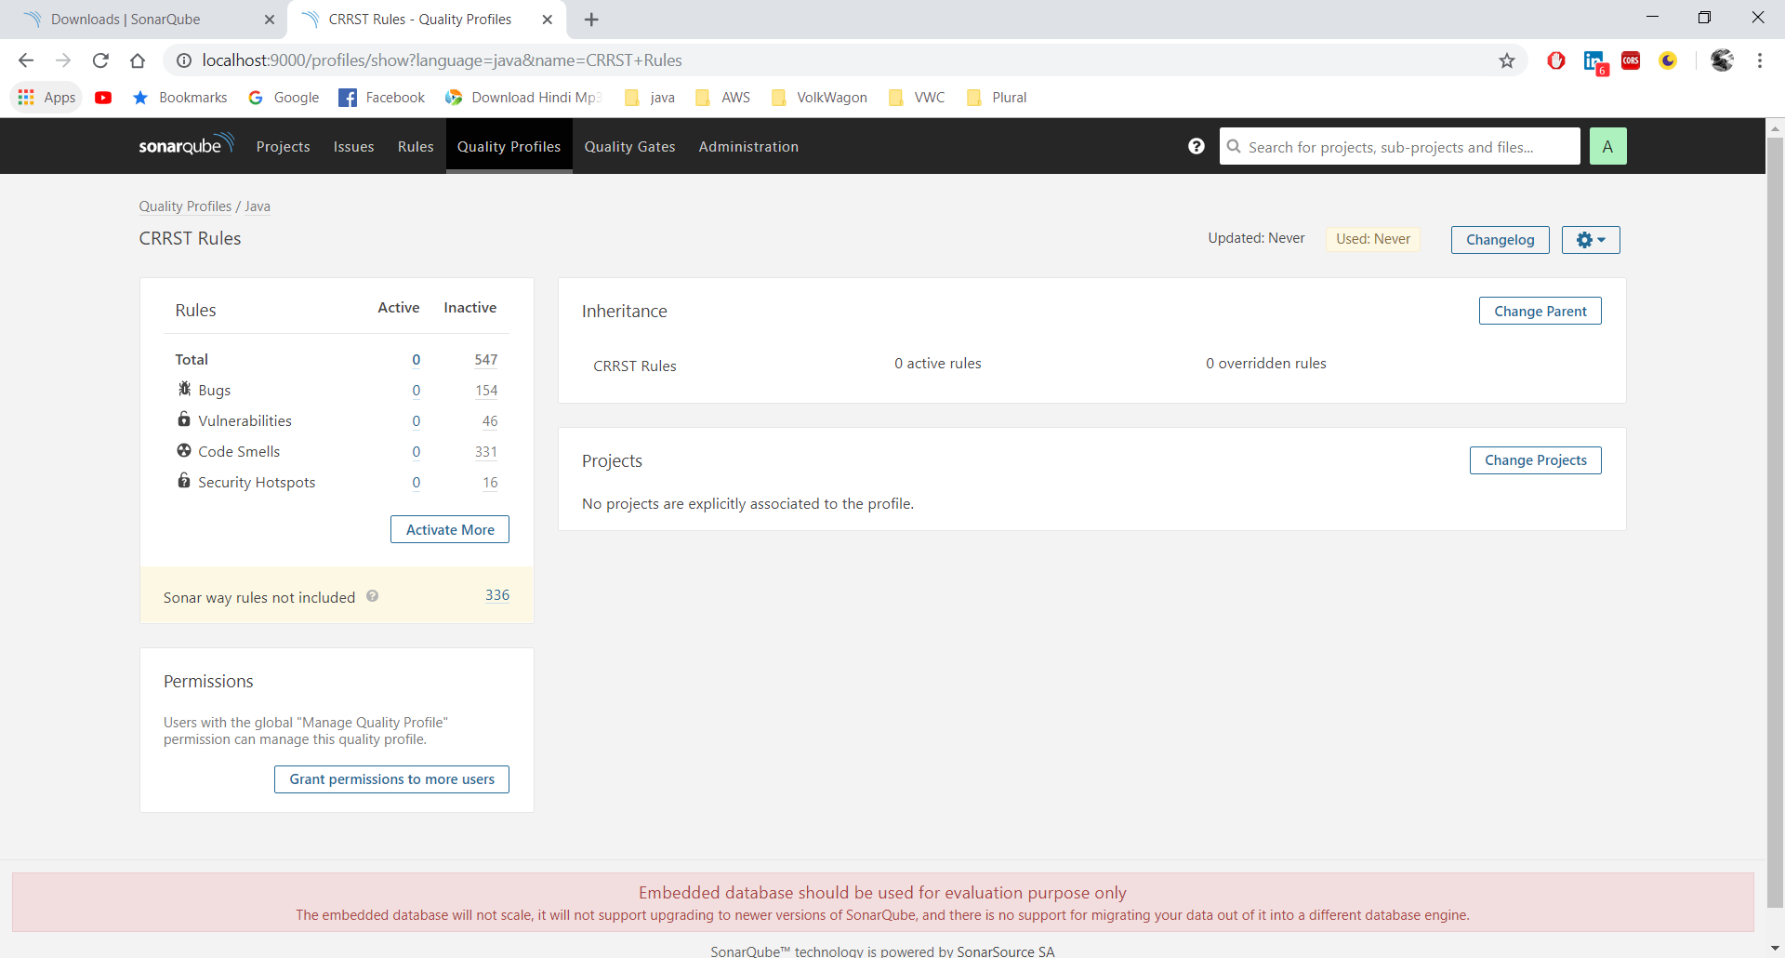

1. To activate rules in this profile, Click on Activate more & it will redirect to the rules page.

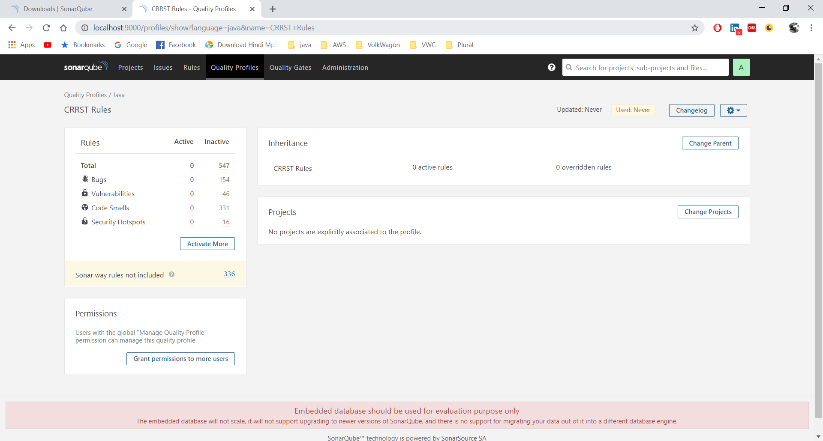

1. On rule page, filter language by java and repository, Click on Repository

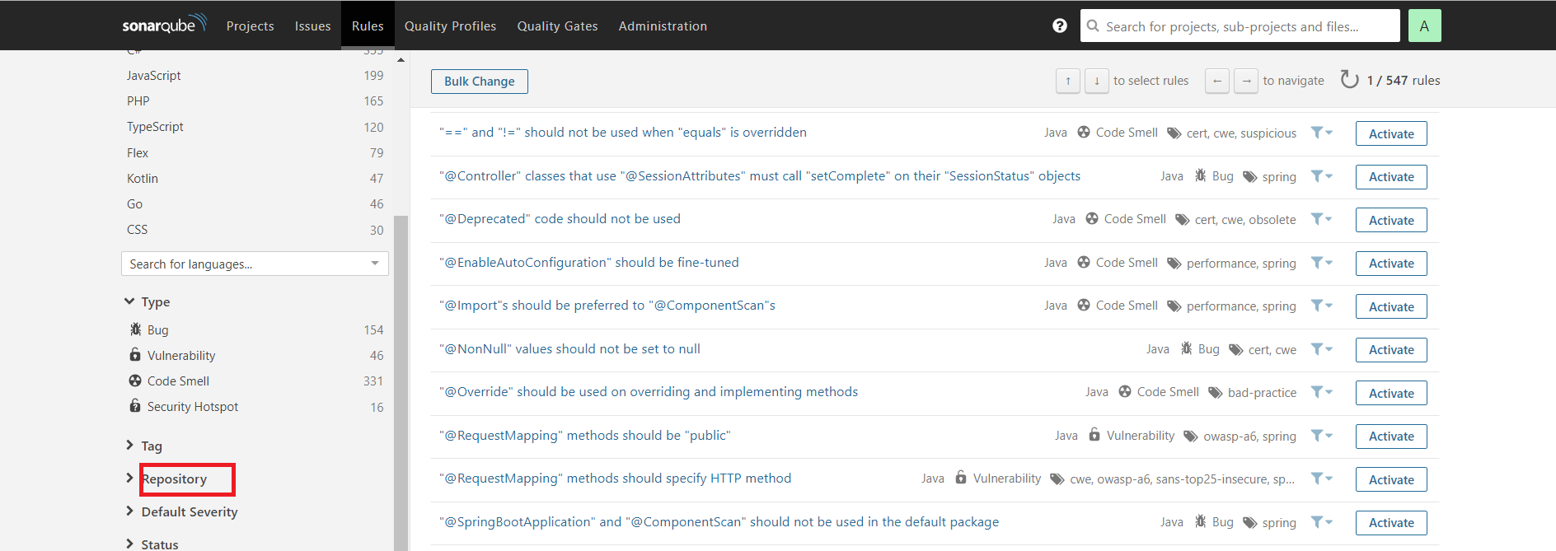

1. Click on CG java repository to active CRRST rules for java applications.

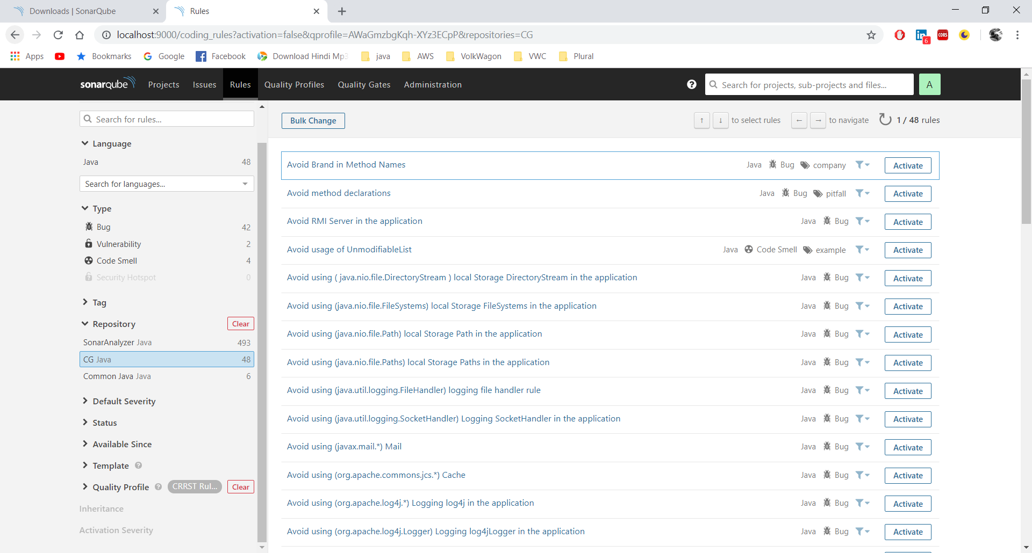

Note: CG repository is custom repository created by CRRST Team.

1. Click on Bulk Chnage and then click on Active in CRRST Rules.

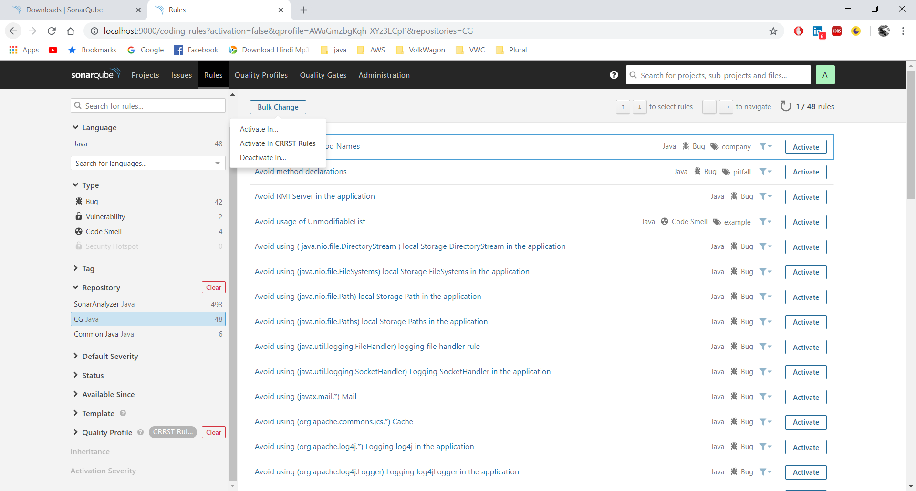

1. Click on Apply.

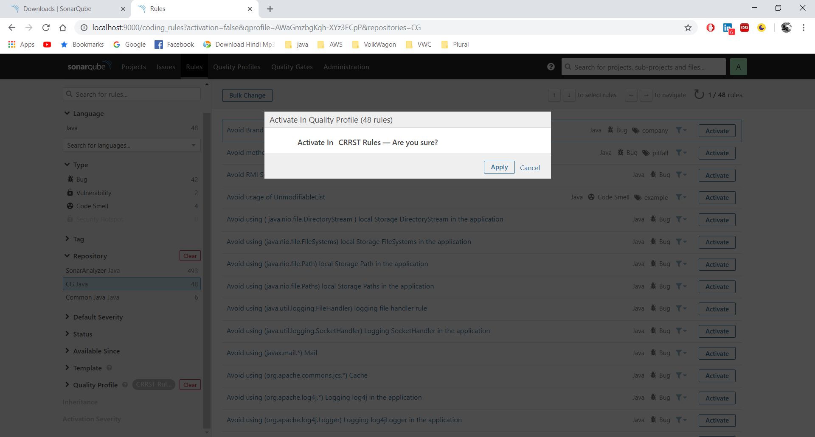

1. It will show rules activated , click on Close.

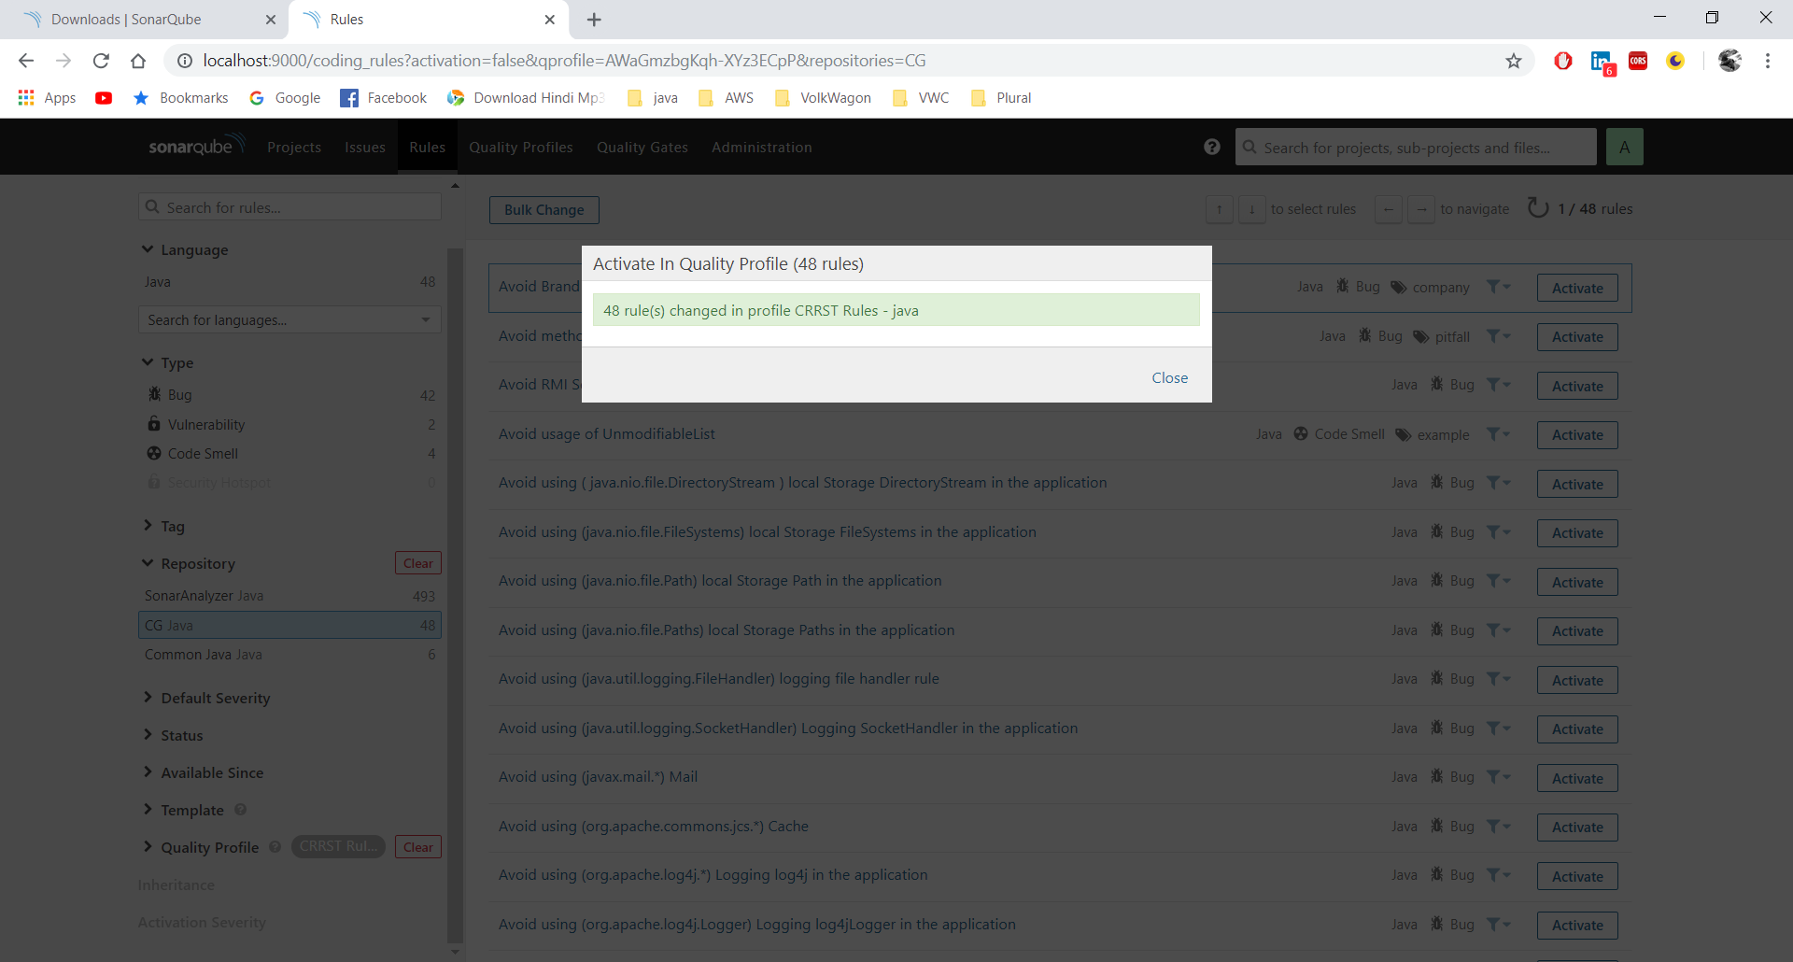

1. When you click **quality profile 🡪 CRRST Rules java**, **i**t will show new added rule(CRRST Rule) in Quality Profile.

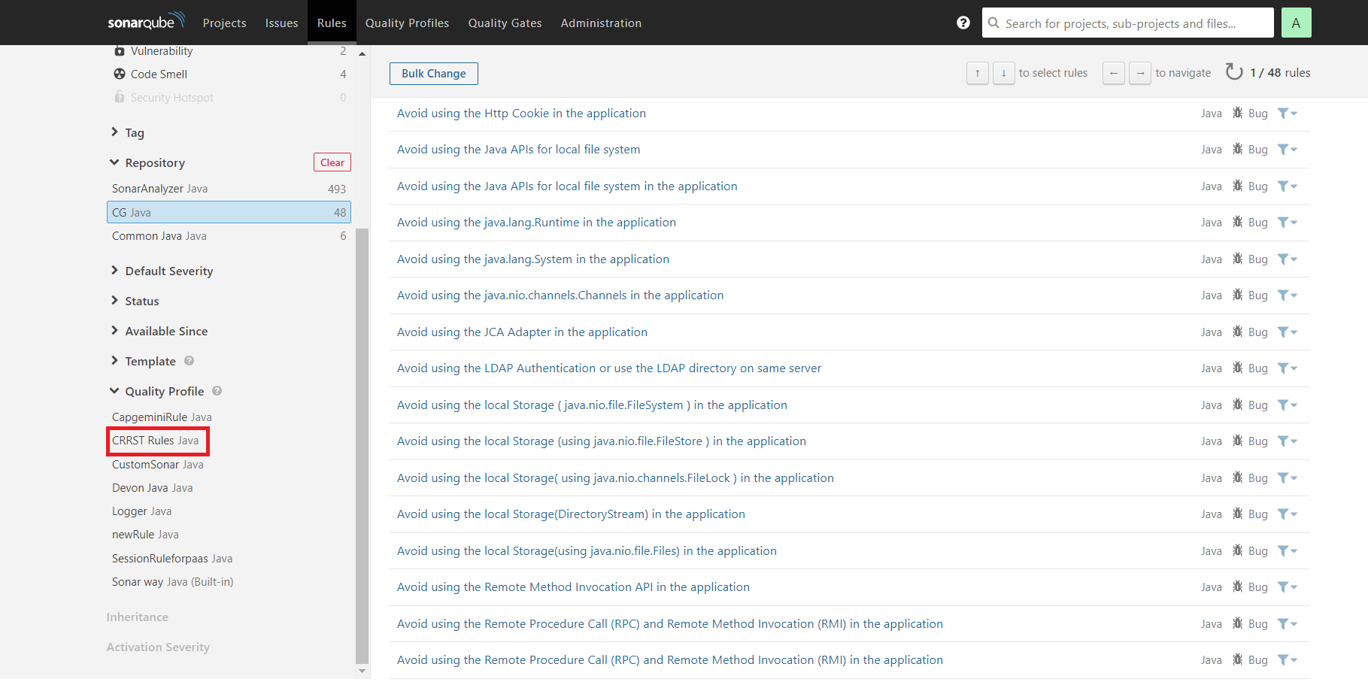

1. As shown in below screen shot All rules under CRRST Rules got activated .

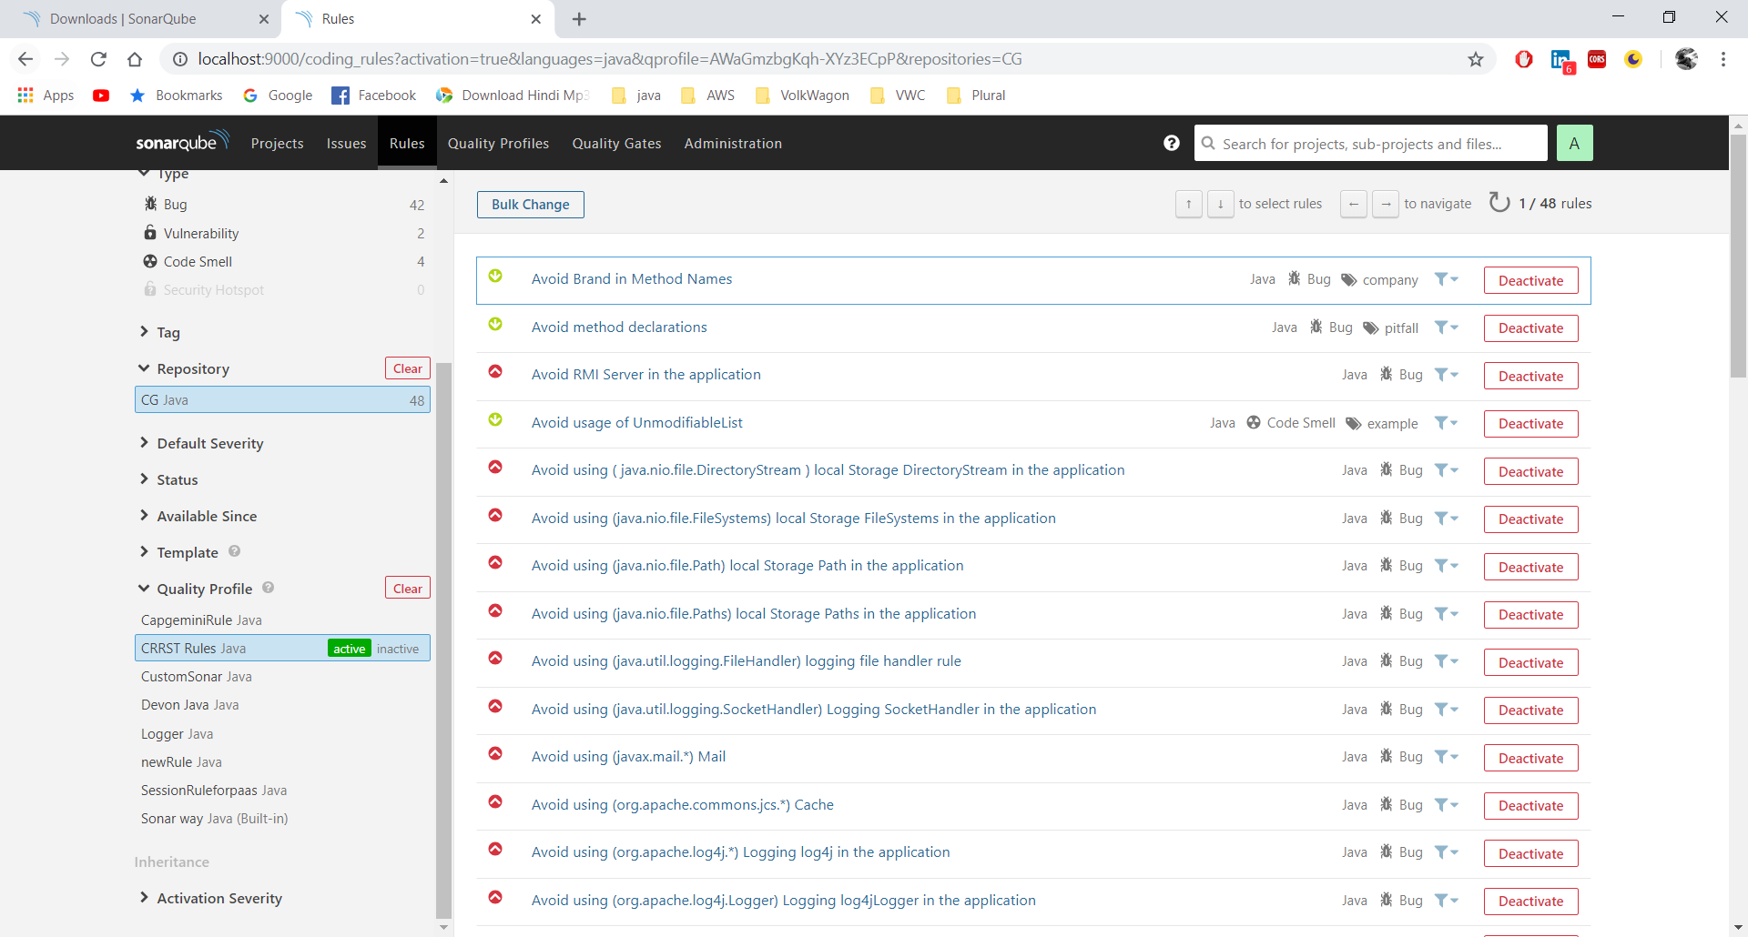

1. Go to **Quality Profile-> new added Rule(CRRST Rules) ->setting -> set as default**

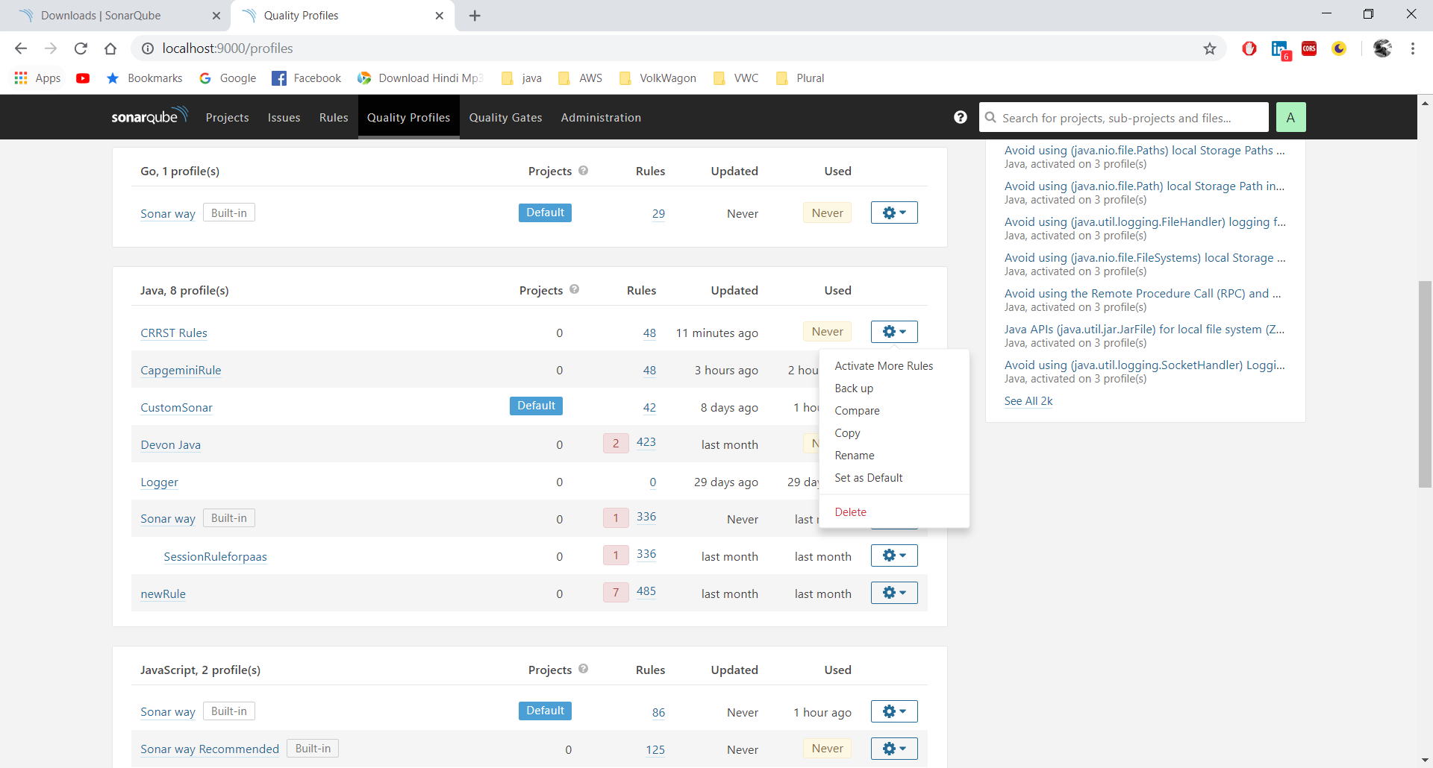

1. As shown in the below screenshot CRRST rule has set default.

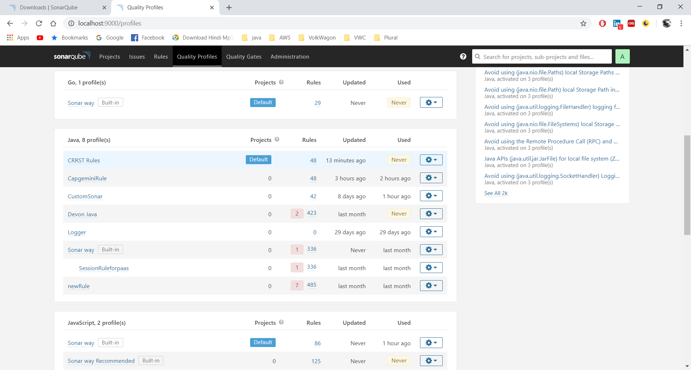

# Steps to scan java project in CRRST TOOL

1. Open command promt and go to your maven project directory .Run your maven project using command **clean install.** Then Run command **mvn sonar:sonar** (It will start scanning your project code)

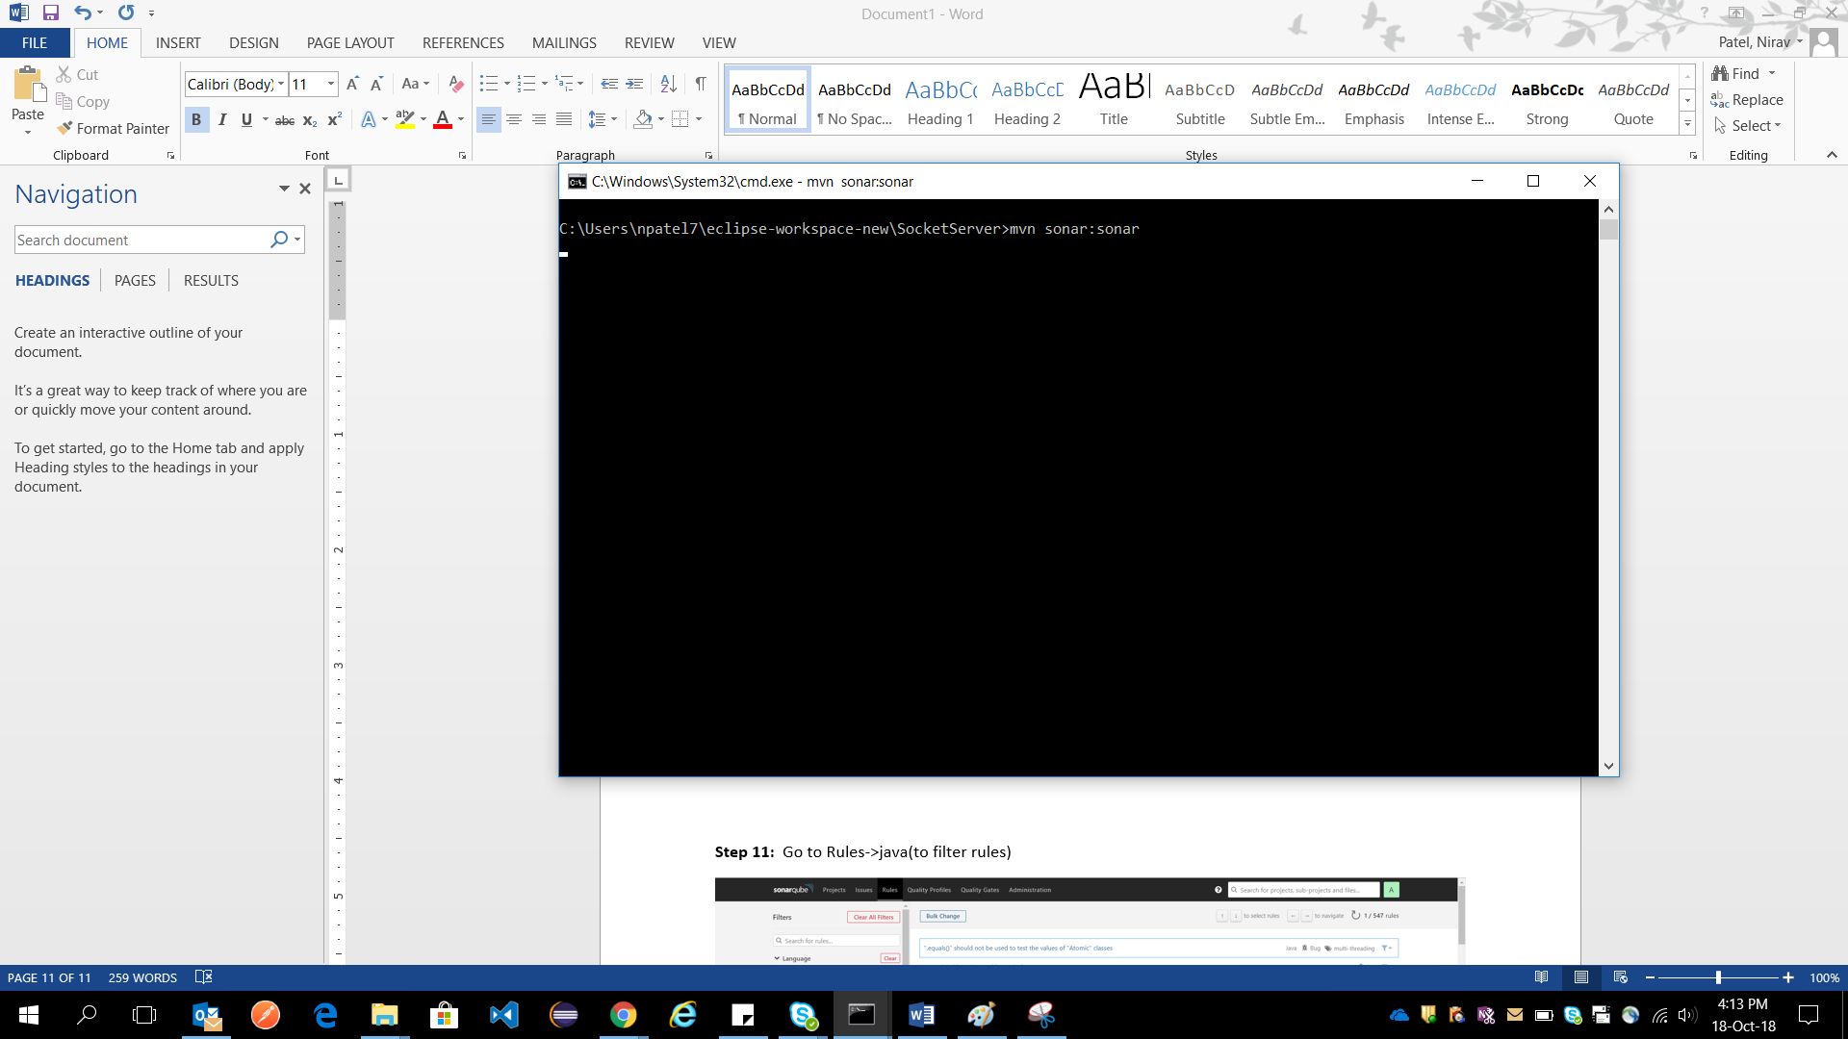

1. It will show BUILD SUCCESS

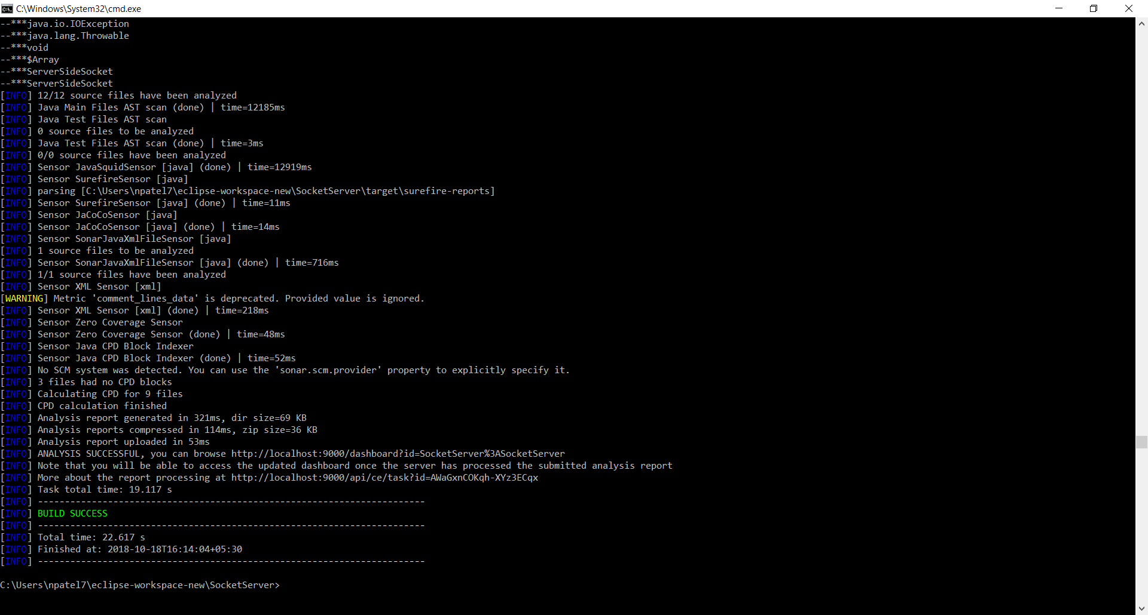

1. Once the project got scanned, Go to sonarQube ->Project and select your project.

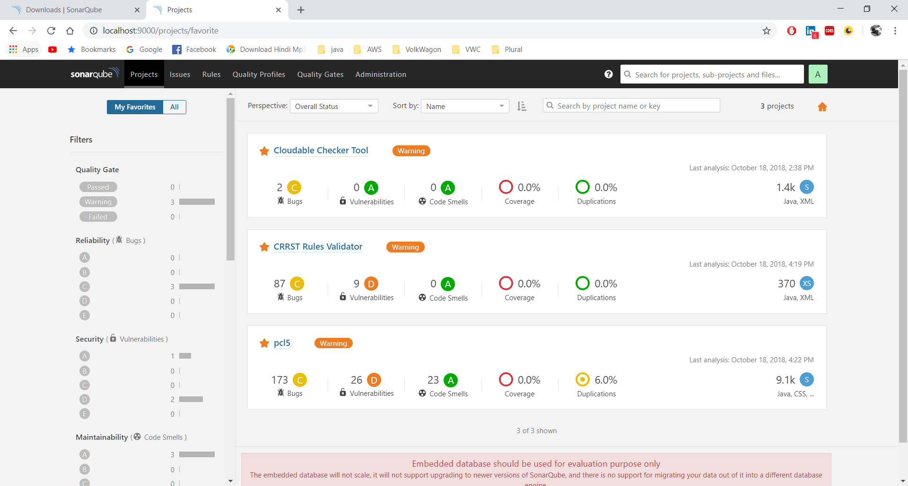

1. In overview it will show number of bugs, code smells, coverage, Duplications.

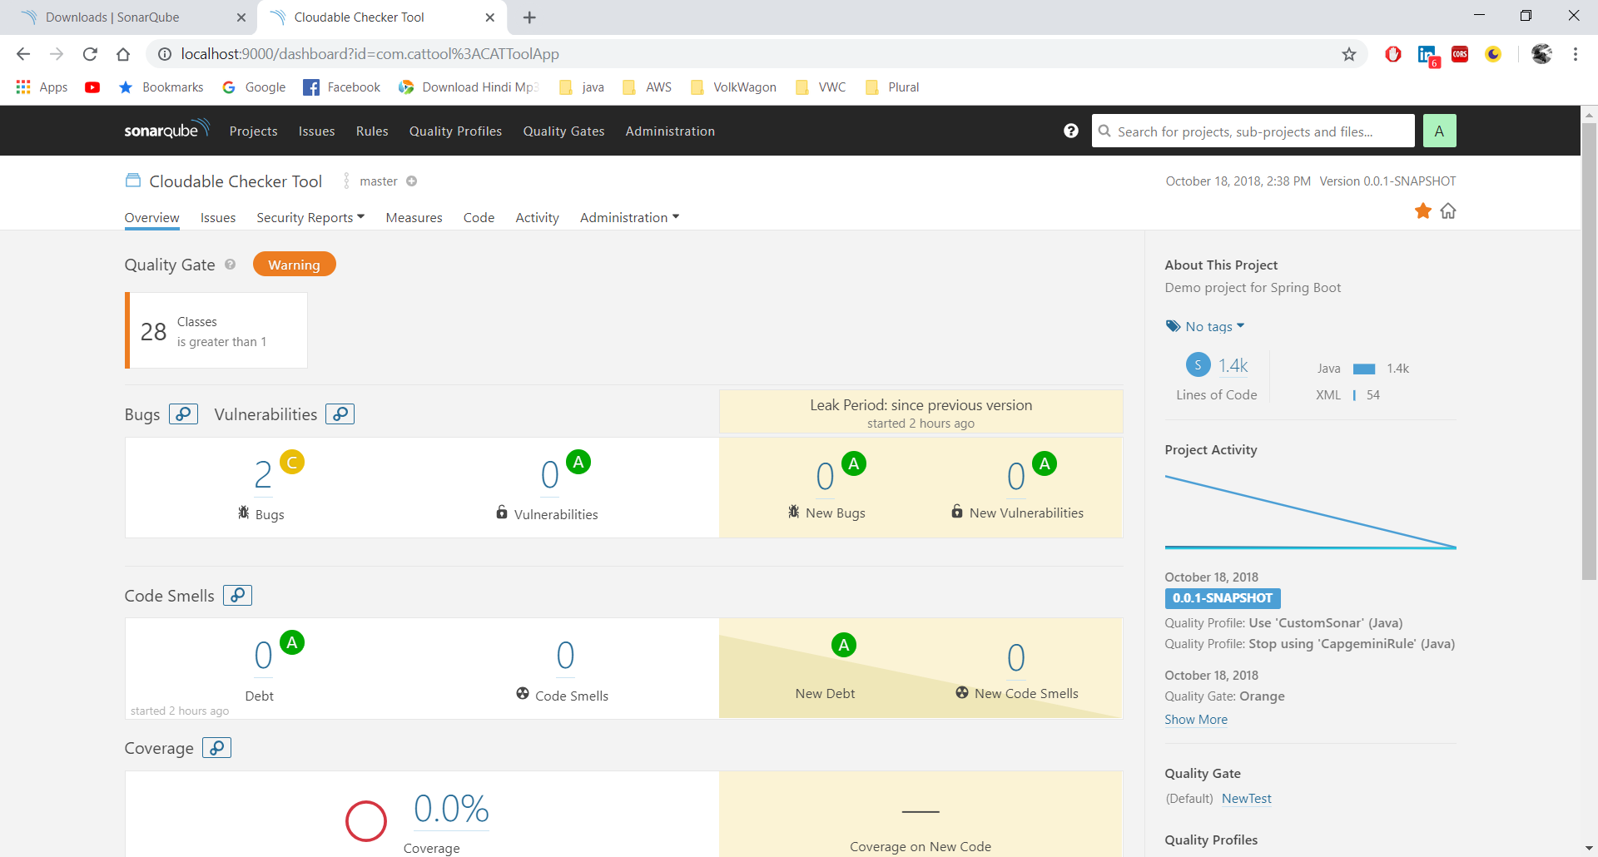

1. In issue it shows list of issues.

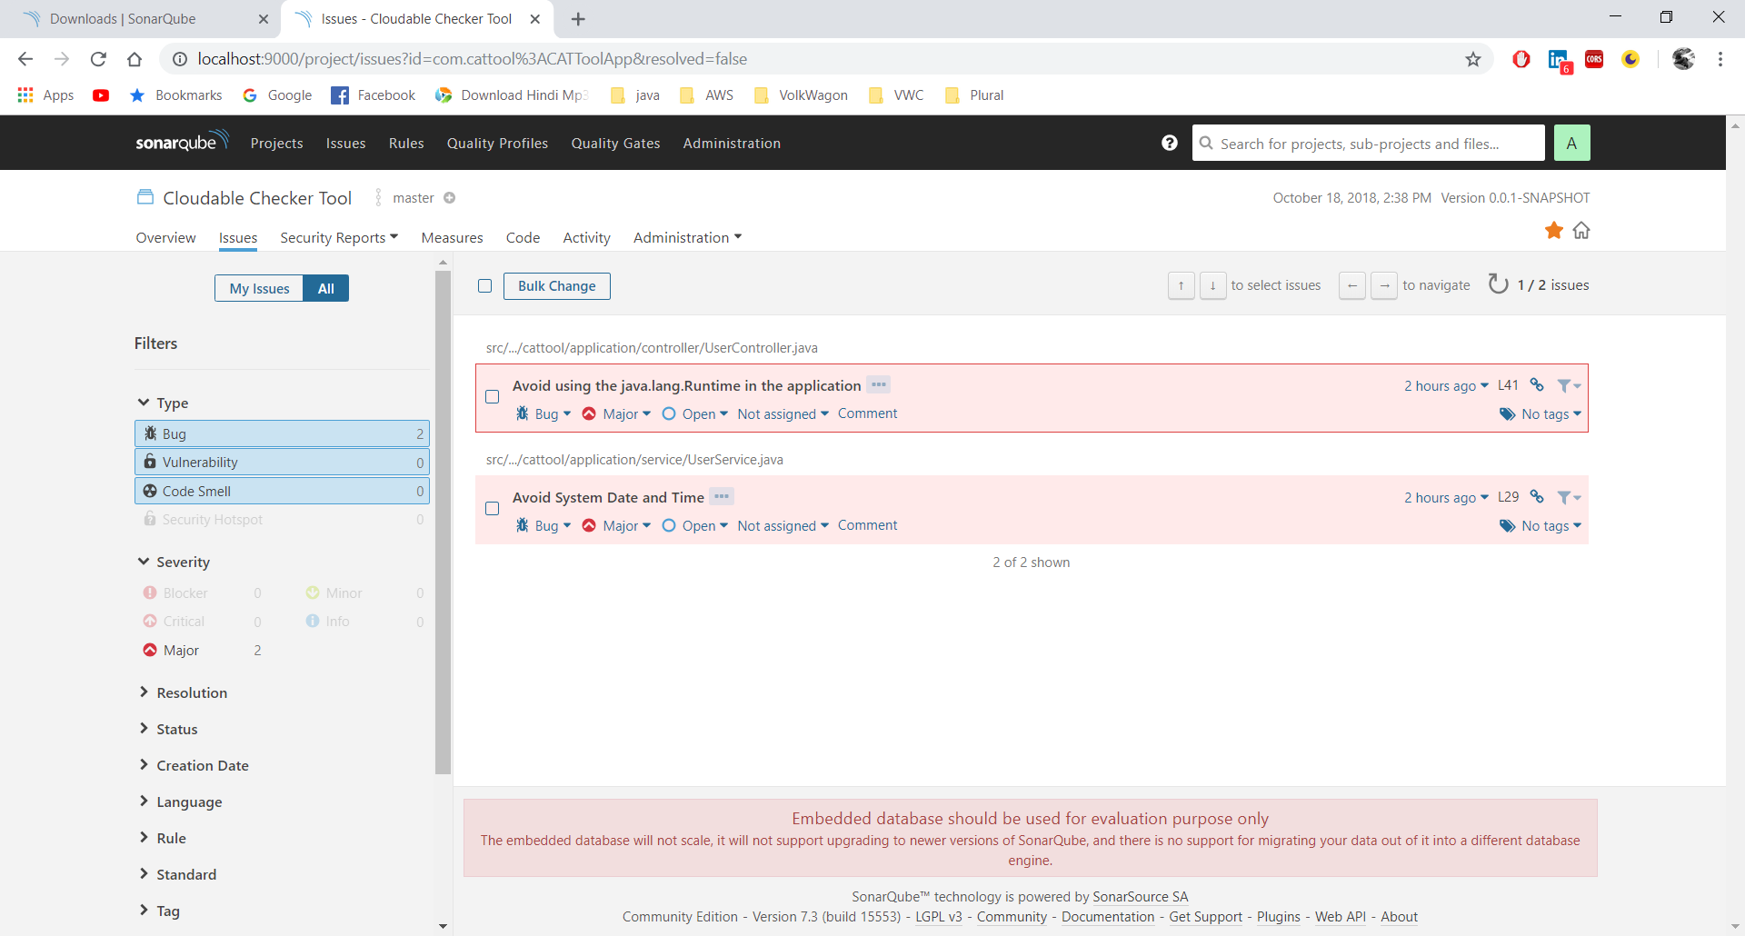

1. In code it will show detailed information like lines of code, bugs, vulnerabilities, code smells, coverage, duplication of individual file in project.

